Weekly Task Report
Geo Learn
12/4/19


Mentor: Fabio Santos
Sponser: Dr. Chris Doughty
Team members: Samuel Prasse (lead), Kaitlyn Grubb,
Tyler Pehringer, Joshus Tenakhongva

 | Weekly Team Task Report | #10

Team: GeoLearn |  |  |  |  |  | Date: 11/6/19
Project Title: Improving elementary education with custom online enironmental science lectures

 | Samuel Prassse  Present  On-time |  | Kaitlyn Grubb  Present  On-time | 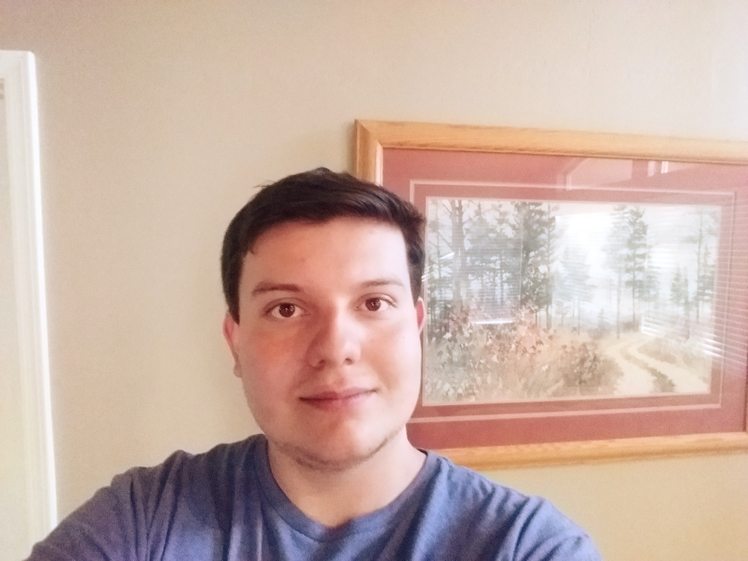 | Tyler Pehringer  Present  On-time |  | 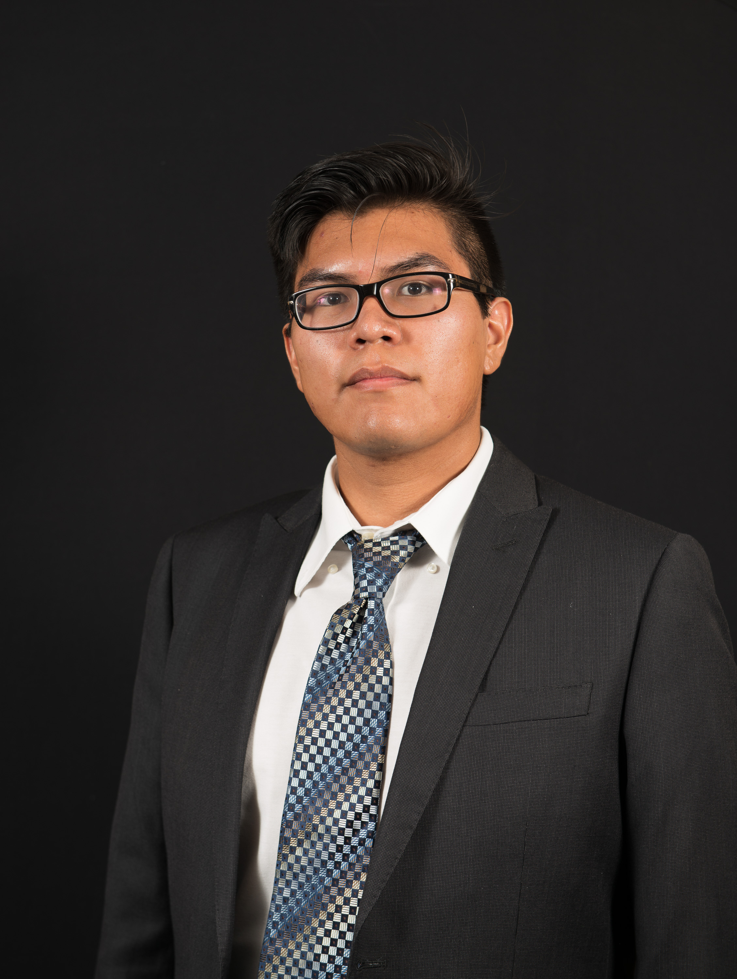 | Joshus Tenakhongva  Present  On-time

Recent Meetings:
- General Team Meeting
- Sponsor Meeting

TASKS COMPLETED since last meeting:
Task Title: Requirements Specification Draft | Task Initiation: 10/30 | Orig. Due Date: 11/29 | Status: In Progress
Who (%): Joshus (25%), Kaitlyn (25%), Tyler (25%), Samuel (25%)
Description: The requirements specification is a description of our project’s requiremtnts, both functional and non-functional, and forms the contractural basis for the expectations to be fulfilled by the development team.
Expected Outcome: Create a document outlining the requirements that the team will stick to when developing our project.

Task Title: Design Review 1 / Presentation | Task Initiation: 11/11 | Orig. Due Date: 11/29 / 11/22 | Status: In Progress
Who (%): Joshus (25%), Kaitlyn (25%), Tyler (25%), Samuel (25%)
Description: This document and presentation will consist of an introduction, discussion of the problem statement, our overview of our solution to the problem, key requirements, risks and feasibility, a schedule for the remainder of the semester, and a conclusion. The presentation will be done in class on the 22nd of November.
Expected Outcome: Create a document outlining the requirements that the team will stick to when developing our project. / Present to a mentor and classmates that are not as familiar with our project, and tell them what our longterm plan is.

Task Title: Peer Eval #3 | Task Initiation: 11/18 | Orig. Due Date: 11/29 | Status: In Progress
Who (%): Team (100%)
Description: An accurate representation of effort and time invested by individual team members as graded by the other 3 team members.
Expected Outcome: Send an excel document to our team mentor with a correct peer evaluation of all team members.

This week’s Tasks: Work plan for coming week
Task Title: Requirements Specification Final | Task Initiation: 10/30 | Orig. Due Date: 11/22 | Status: In Progress
Who (%): Joshus (25%), Kaitlyn (25%), Tyler (25%), Samuel (25%)
Description: The requirements specification is a description of our project’s requiremtnts, both functional and non-functional, and forms the contractural basis for the expectations to be fulfilled by the development team.
Expected Outcome: Create a document outlining the requirements that the team will stick to when developing our project.

Task Title: Peer Eval #4 | Task Initiation: 11/4 | Orig. Due Date: 11/8 | Status: In Progress
Who (%): Team (100%)
Description: Each team member will fill out a peer eval and send it to Fabio by November 8th.
Expected Outcome: An accurate representation of effort and time invested by individual team members as graded by the other 3 team members.

Upcoming Tasks: Planning
Task Title: Tech Demo | Who (%): Team (100%) | Rough Due Date: 11/22
Description: Demo of the current state of our applciation.

Other Problems / Other Issues:
- Edits to the Req Doc

